**CHAPTER 3**

**REFERENCE COORDINATE MODELS OF THE INDUCTION MACHINE**

A dynamic model for the three-phase induction machine can be derived from the two-phase machine if the equivalence between three and two phases is established. The equivalence is based on the equality of the mmf produced in the two-phase and three-phase windings and equal current magnitudes. In order to reduce the expressions of the phase coordinate mode of the induction motor equation voltages given in equation 2.55 to equation 2.60 and obtain constant coefficients in the differential equations, the Park's transformation can be applied to the phase coordinate model (ABC) of any symmetrical induction machine.

**3.1 Arbitrary reference coordinate model**

Reference frames are very much like observer platforms, in that each platform gives a unique view of the system at hand as well as a dramatic simplification of the system equations. Different reference frames have different advantages to offer. Instead of deriving the transformations for each and every particular reference frame, it is advantageous to derive the general transformation for an arbitrary rotating reference frame. Then, any particular reference frame model can be derived by substituting the appropriate frame speed and position in the generalised reference model.

The direct (d) and quadrature (q) axes mmfs are found by resolving the mmfs of the three phases along the d and q axes. Fig-3.1 shows a schematic of a 3-phase induction motor with the q,d axes superimposed. The d axis lags the q axis by 90° (electrical). The q axis is assumed to be lagging the A-axis by θq. Coils QS, DS, qr, dr replace the real phase coils As, Bs, Cs, ar, br, cr. The relationship between dq0 and ABC currents is as follows;

 (3.1)



 (3.2)

The current i0 represents the imbalances in the a, b, and c phase currents and can be recognised as the zero-sequence component of the current. The zero-sequence current does not produce a resultant magnetic field.

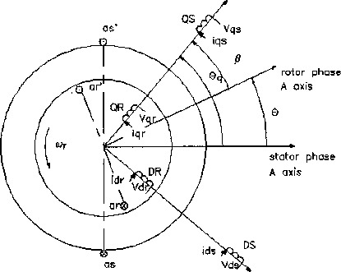

Fig-3.1The schematic diagram of a 3-phase induction motor for d-q model

The transformation from two-phase to three-phase currents is obtained as follows:

 (3.3)

The general form of the voltage balance equations for the arbitrary reference frame model is as follows:

 (3.4)

The stator and rotor flux linkages in the arbitrary reference frame are defined as

 (3.5)

And, flux linkage of the arbitrary reference frame,

 (3.6)

First, determine expression of currents in terms of flux linkages as follows;  

From (3.4) and (3.5), we can write

 (3.7)

The induction motor model in arbitrary reference frames is obtained from (3.7) as  (3.8)

The expression for electromagnetic torque however does not depend on the particular reference frame and has the following general form  (3.9)

**3.2 Stationary reference frame (α-β)**

For the stator reference frame model, the speed of the reference frame is that of the stator which is zero, i.e., ωq= 0. So it is usual to align the α axis with the phase A winding. This implies that the α-β frames are fixed to the stator. The model is known as α-β model or the stator reference frames model. The transformation from ABC to αβ0 variables are given as

 (3.11)

3.2.1 **Power equivalence**

The power input to the three phases motor has to be equal to the two phase machine to have a meaningful interpretation in the modelling, analysis and simulation. The three phase instantaneous power input is



 (3.12)

The vector form of the voltage equations for stationary reference frame (α-β) are as follows;

 (3.13)

Where,

  

   

The voltage equations for stationary reference frame (α-β),

 (3.14)

The flux linkages are as follows;

 (3.15)

The stator and rotor currents are as follow;









So, differential equations of the flux linkage of the stator and rotor along stationary reference frame (α-β).

 (3.16)

The matrix form of the voltage equations in stationary reference frame (α-β) is as follow;

 (3.17)

Substituting the above current equations into the torque equation gives the expression for the torque in terms of flux linkages

 (3.18)

where [R] - is 4 by 4 matrix of stator resistances rs, and rotor resistances rr, ;Vms- is the peak value of the stator voltage; ωr - is electrical synchronous speed of the motor.

The expressions for *Vαr* and Vβr depend on the frequency and the phase of the voltage applied to the rotor. Usually for most practical applications of the stationary frame, Vαr = Vβr=0.

Fig -3.3 shows the results of the computer simulation of start up currents of the 1.7 kW induction motor in the stationary reference frame. The α-axis stator variables of the stationary reference frame behave in the same way as do the physical stator variables (ABC). In particular, the iαs current coincides with the actual stator phase A current (Fig 2.6).

Therefore this model is advantageous when only transients in the stator are of interest as in the case of studying stator transients of squirrel cage induction motors.

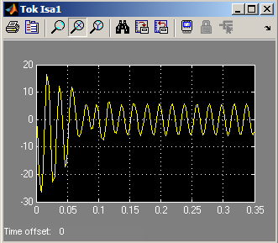

Fig-3.3 stator current using stationary reference frame

**2.4 Rotor reference frame (d-q)**

For the rotor reference frame model, the speed of the reference frame is that of the rotor which is ωr, i.e., ωq =ωr

 (3.19)

Where



The voltage equations for rotor reference frame (d-q),

 (3.20)

The flux linkages are as follows;

 (3.21)

The stator and rotor currents are as follow;













So, differential equations of the flux linkage of the stator and rotor along rotor reference frame (d-q).

 (3.22)

The matrix form of the voltage equations in rotor reference frame (d-q) is as follow; 

(3.23);*θ*ris the angle between stator and rotor phase A axes.

Substituting the above current equations into the torque equation gives the expression for the torque in terms of flux linkages,

 (3.24)

The rotor reference frame applies to the description of energy conversion process in synchronous machines. This reference frame is convenient for use in the analysis of salient pole machine, where the coordinates extend along the d axis and q axis of the machine.

**2.5 Synchronously rotating reference frame (u-v)**

For the synchronously reference frame model, the speed of the reference frame is that of the synchronous speed which is ωs, i.e., ωq= ωs

(3.25)

Where



The voltage equations for synchronously rotating reference frame (u-v),



 (3.26)

The flux linkages are as follows;

 (3.27)

The stator and rotor currents are as follow;













So, differential equations of the flux linkage of the stator and rotor along synchronously rotating reference frame (u-v).

 (3.28)

The matrix form of the voltage equations in synchronously rotating reference frame (u-v) is as follow;

 (3.29)

Where Vus=Vms;Vvs=0.Substituting the above current equations into the torque equation gives the expression for the torque in terms of flux linkages,

 (3.30)

The synchronously rotating reference frame rotating at an arbitrary speed finds use for the analysis of machines where both the stator and rotor are rotating members.